StockiFy – Annual Stock Market Simulation
StockiFy is the annual flagship stock market simulation event hosted by the Finance Committee of FOSTIIMA Business School every January. The event provides students with an immersive platform to apply their knowledge of financial markets, instruments, and business developments through an engaging Ring Trading experience. A key highlight is the in-house stock market simulation software developed by FOSTIIMA’s own students, enabling participants to experience real-time trading and make strategic Buy, Sell, or Hold decisions. StockiFy promotes financial literacy, teamwork, analytical thinking, quick decision-making, and practical understanding of stock market dynamics in an exciting competitive environment.

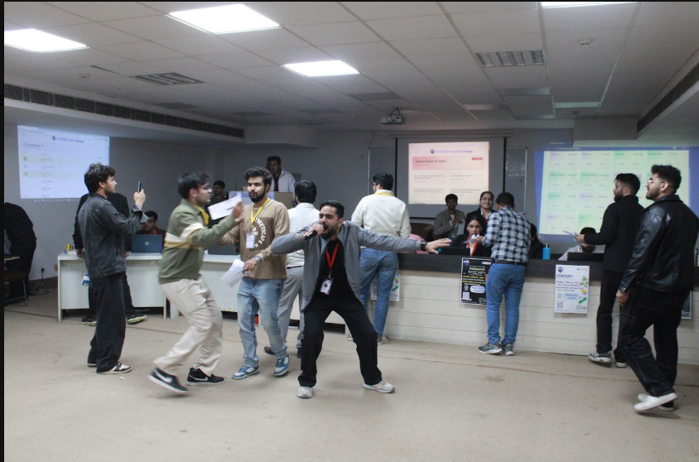
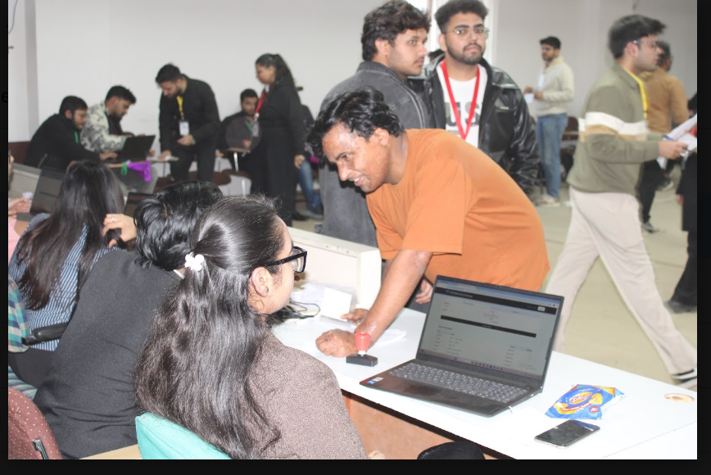
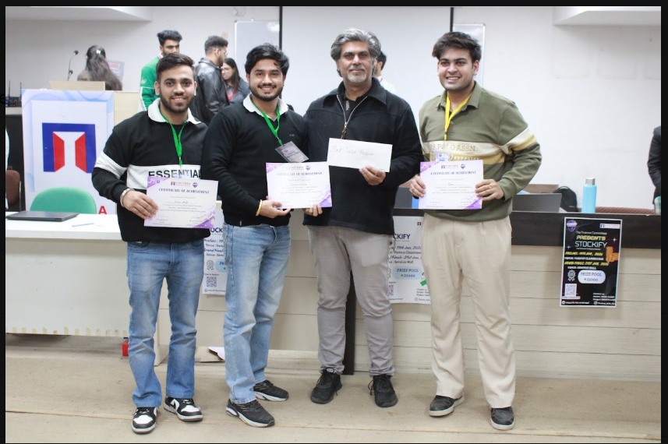
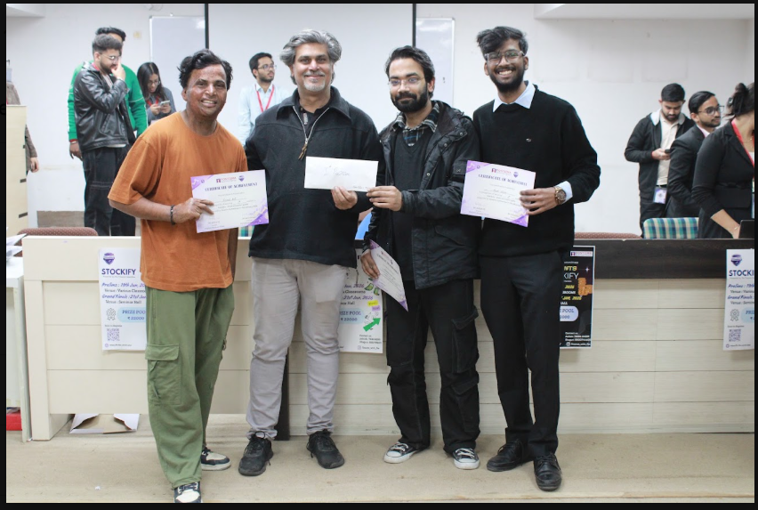
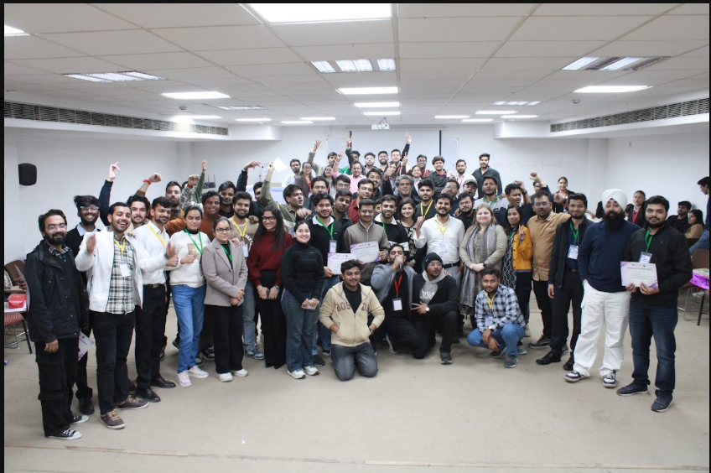

FinQuest, the annual finance quiz organized by the Finance Committee of FOSTIIMA Business School, is conducted every year to provide students with an engaging platform to showcase their knowledge of finance, economics, business, and current affairs. The competition begins with an objective-based preliminary round, followed by a challenging finale for the top-performing teams. The final round features engaging segments such as Voice and Image Identification, Business Trivia, and Rapid-Fire, creating an energetic and competitive learning environment. FinQuest encourages financial literacy, teamwork, analytical thinking, quick decision-making, and healthy competition, while making finance learning interactive and enjoyable.


